Jacqueline Jones PhD RN FAAN
An Ideology of Leadership & Concept Map

NURS 6800 Innovative Leadership
Dr Patricia Abbott

Ideology is a system of ideas that are dynamic and are given purpose. This ideology is enmeshed in a chaotic network and interplay of people, individual and shared purpose, and conflict. Leadership is all about relationships (Kouzes & Posner, 2023 p.18). The concept map illustrates the complexity of networks and relationships among the ideas as ‘messy’, chaotic yet connected to values. Values that bring light to leadership are those that are linked to the human face of work and inspiration: meeting people where they are at. My values are creativity, humility, authenticity, empowerment, trust, and kindness. This aligns with human-centered leadership as the Awakener, Connector and Upholder (Leclerc et al., 2021).
As a Caritas Coach I live through human connection, in right relation to others and embrace non local consciousness and webs of interconnectedness. Wisdom leadership includes ‘the ability to reflect, forgive, and be humble, trustworthy, compassionate, relationship-oriented and positive’ (Wei & Horton-Deutsch, 2022, p.444). Quantum leadership observes that reality is complex and unfolding and is a web of interconnected relationships, but that failure is normative (Albert, et al., 2022, p.593, p.600). Trying new ideas and taking risks towards innovation involves failure and being a leader means embracing failure, losses and allowing for growth through course correction. Course correction does not imply a linear direction only that the journey moves onwards. Using these concepts the overarching goal is to work towards ‘helping others to act’ (Kouzes & Posner, 2023) seen by a central concept in this ideology of Mobilize strengths in others.
Human worth, humility, authenticity, and compassion characterize values and beliefs that infuse interconnectedness I seek to engage as a leader to see and support that strength in others (Watson et al., 2018; Wei & Horton-Deutsch, 2022). Humanistic wisdom and innovation culture change are embodied through personal and collective action, and inaction. I strive to be a lifelong learner and employ coaching and mentoring others as they grow and thrive within their own leadership journey. Learner, Ideation and Futuristic are part of Strategic Thinking (Rath & Conchie, 2008) that guides a network of my own ideas and those of others as we seek to Achieve. Attributes such as gratitude and humility are part of the human connectedness from Caring Science (Watson et al., 2018), Wisdom leadership (Wei & Horton-Deutsch, 2022) and the understanding of quantum leadership as networks of people, relationships, dynamic communication and interactions and the positive place of conflict (Albert et al, 2021). These ideas provide a credible platform and pillars to signpost the vision for leadership I hold for myself and others.
New understandings include the place of intergenerational workspaces and how what I have learned before may not hold for the future such that different generations need to be led with Wisdom and humility while letting them find the value in the interaction for themselves (Anderson et al., 2017; Weston, 2021). Kouzes and Posner (2023) call these modelling the way and enabling others to act yet in this ideology there is always a tension between opportunities and modelling, risk taking and failing. Failure is isolated as a block but in reality it permeates all interactions and possibilities.
Aspirations such as joy at work, meaningful recognition, empowerment, patience, and forgiveness build strength for partnerships in leading, listening and action (Anderson et al., 2017; Weston, 2022). There are feedback loops that connect back between main ideas and actions. Agility, dynamism, stability and clear expectations are a constellation within which quantum thinking builds reflection for ‘extraordinary things to happen’ when we collectively ‘Struggle for our shared vision aspirations’.

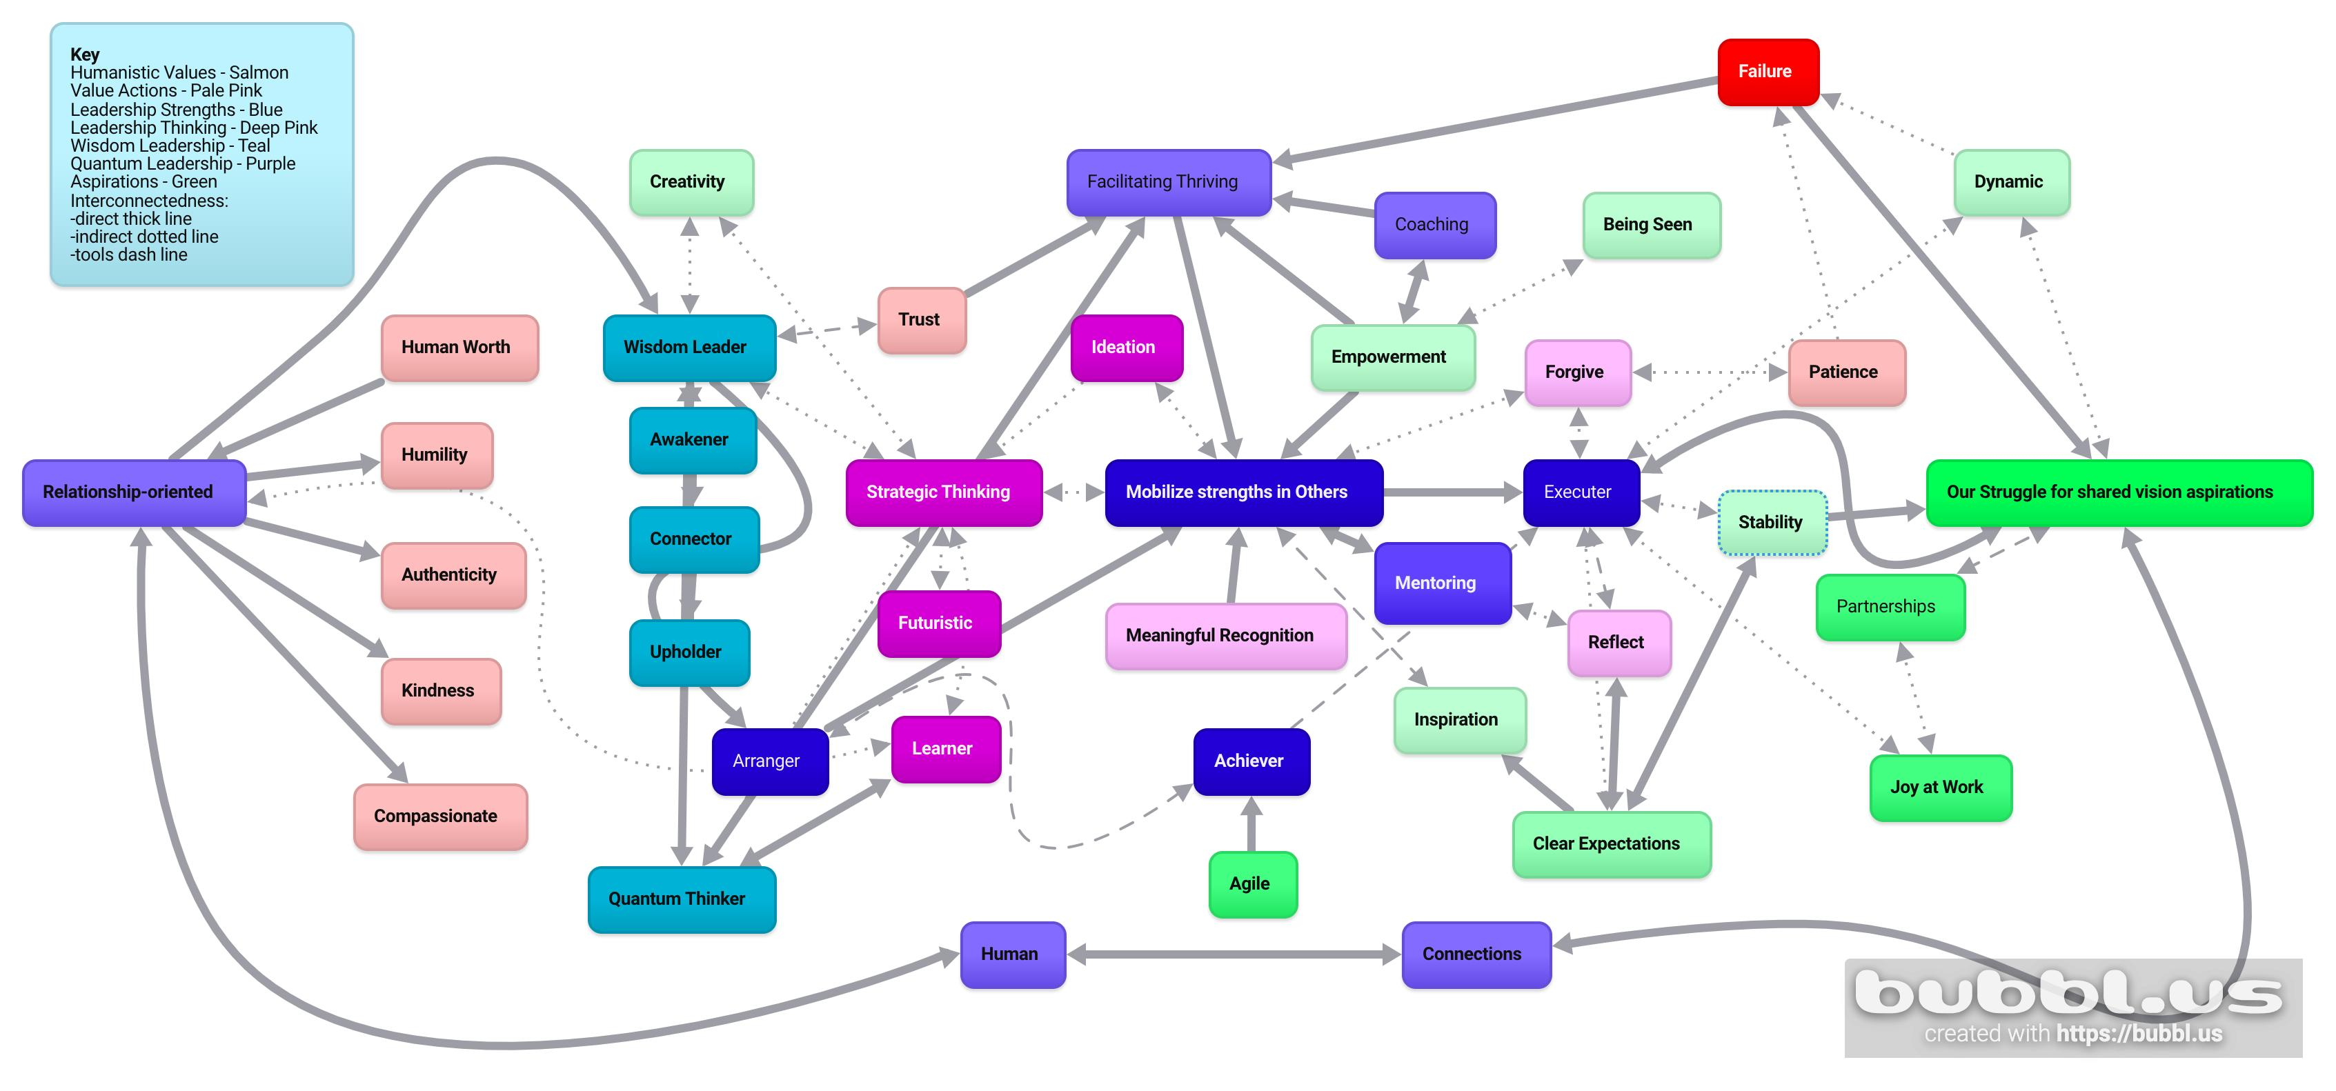

Concept Map of Personal Leadership Ideology

References
Albert, N. Pappas, S., Porter-O'Grady, T., & Malloch, K. (2022). Quantum leadership: Creating sustainable value in health care, 6th ed. Burlington, MA: Jones & Bartlett Learning.
Anderson, H.J., Baur, J.E., Griffith, J.A., & Buckley, M.R. (2017) What works for you may not work for the (Gen)Me: Limitations of present leadership theories for a new generation. The Leadership Quarterly, 28:245-260
Kouzes, J., & Posner, B. (2023). The Leadership Challenge: How To Make Extraordinary Things Happen in organizations (7th ed.). John Wiley & Sons
Leclerc, L., Kennedy, K., & Campis, S. (2021) Human-centered leadership in health care: A contemporary nursing leadership theory generated via constructivist grounded theory. Journal of Nursing Management, 29: 294-306.
Rath, T., & Conchie, B. (2008). Strengths based leadership: Great Leaders, teams, and why people follow. Gallup Press.
Watson J, Porter-O’ Grady T, Horton-Deutsch S, Malloch K. (2018). Quantum Caring Leadership: Integrating Quantum Leadership With Caring Science. Nursing Science Quarterly. July (3). https://journals-sagepub-com.proxy.hsl.ucdenver.edu/doi/full/10.1177/0894318418774893
Wei, H. & Horton-Deutsch, S. (2022). Visionary Leadership in Healthcare. Indianapolis, IN: Sigma Theta Tau International.
Weston, M. (2022) Strategic planning for a very different nursing workforce. Nurse Leader www.nurseleader.com April, pp152-160. Accessed September, 8th, 2023

